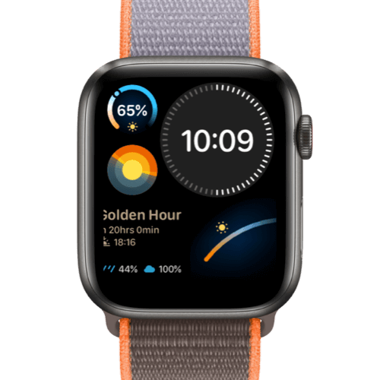**Description :** GOLDEN HOUR is a watch brand known for its stylish and affordable timepieces, blending modern design with functionality. The brand offers a range of watches, including sports, casual, and fashion-forward styles, often featuring stainless steel cases, chronograph functions, and luminous hands for readability in low light. GOLDEN HOUR watches are popular for their durability, water resistance, and budget-friendly pricing, making them an excellent choice for those seeking a stylish yet affordable timepiece.